Movie Reviews

1. Read the film review. Does the writer answer all these questions? Check and tick ()

  - What is the title of the film?
  - What genre is it?
  - What is it about?
  - Is it based on a book?
  - Where is the film set?
  - When is the film set?
  - Who stars in the film?
  - Who plays the main role(s)?
  - Who is your favorite character in the film? (Why?)
  - What kind of person would like this film?

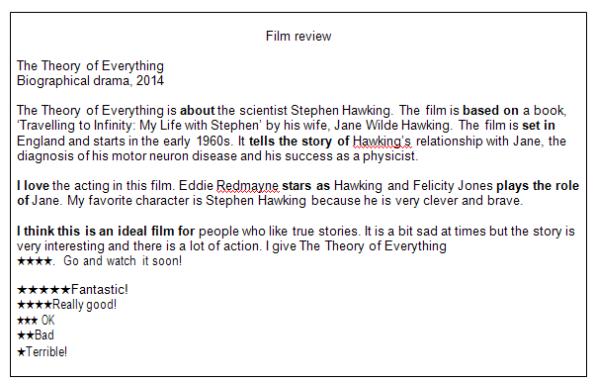

2. Follow the steps to write your own film review.

- Think of a film you have watched.
- Make notes for each of the questions in Activity 1.
- Write your review using your notes and the model text. Use some of the words and phrases in bold. Write between 100 and 150 words.
- You may do this task individually or in group.

